­­­­­­­

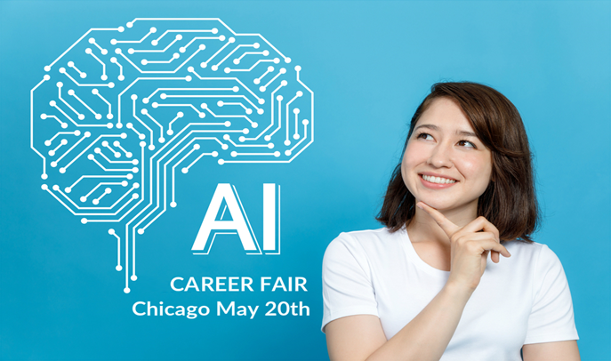

AI Career Days aims to place and retain top talent. It is organized by MARCH and supported by our sponsors

Professionals or students seeking a future in AI can meet employers and network with others in the field

**Brought to you by**



**ChicagoAIDays.com Tweet @chicagoaidays #AIDays #AICareers**